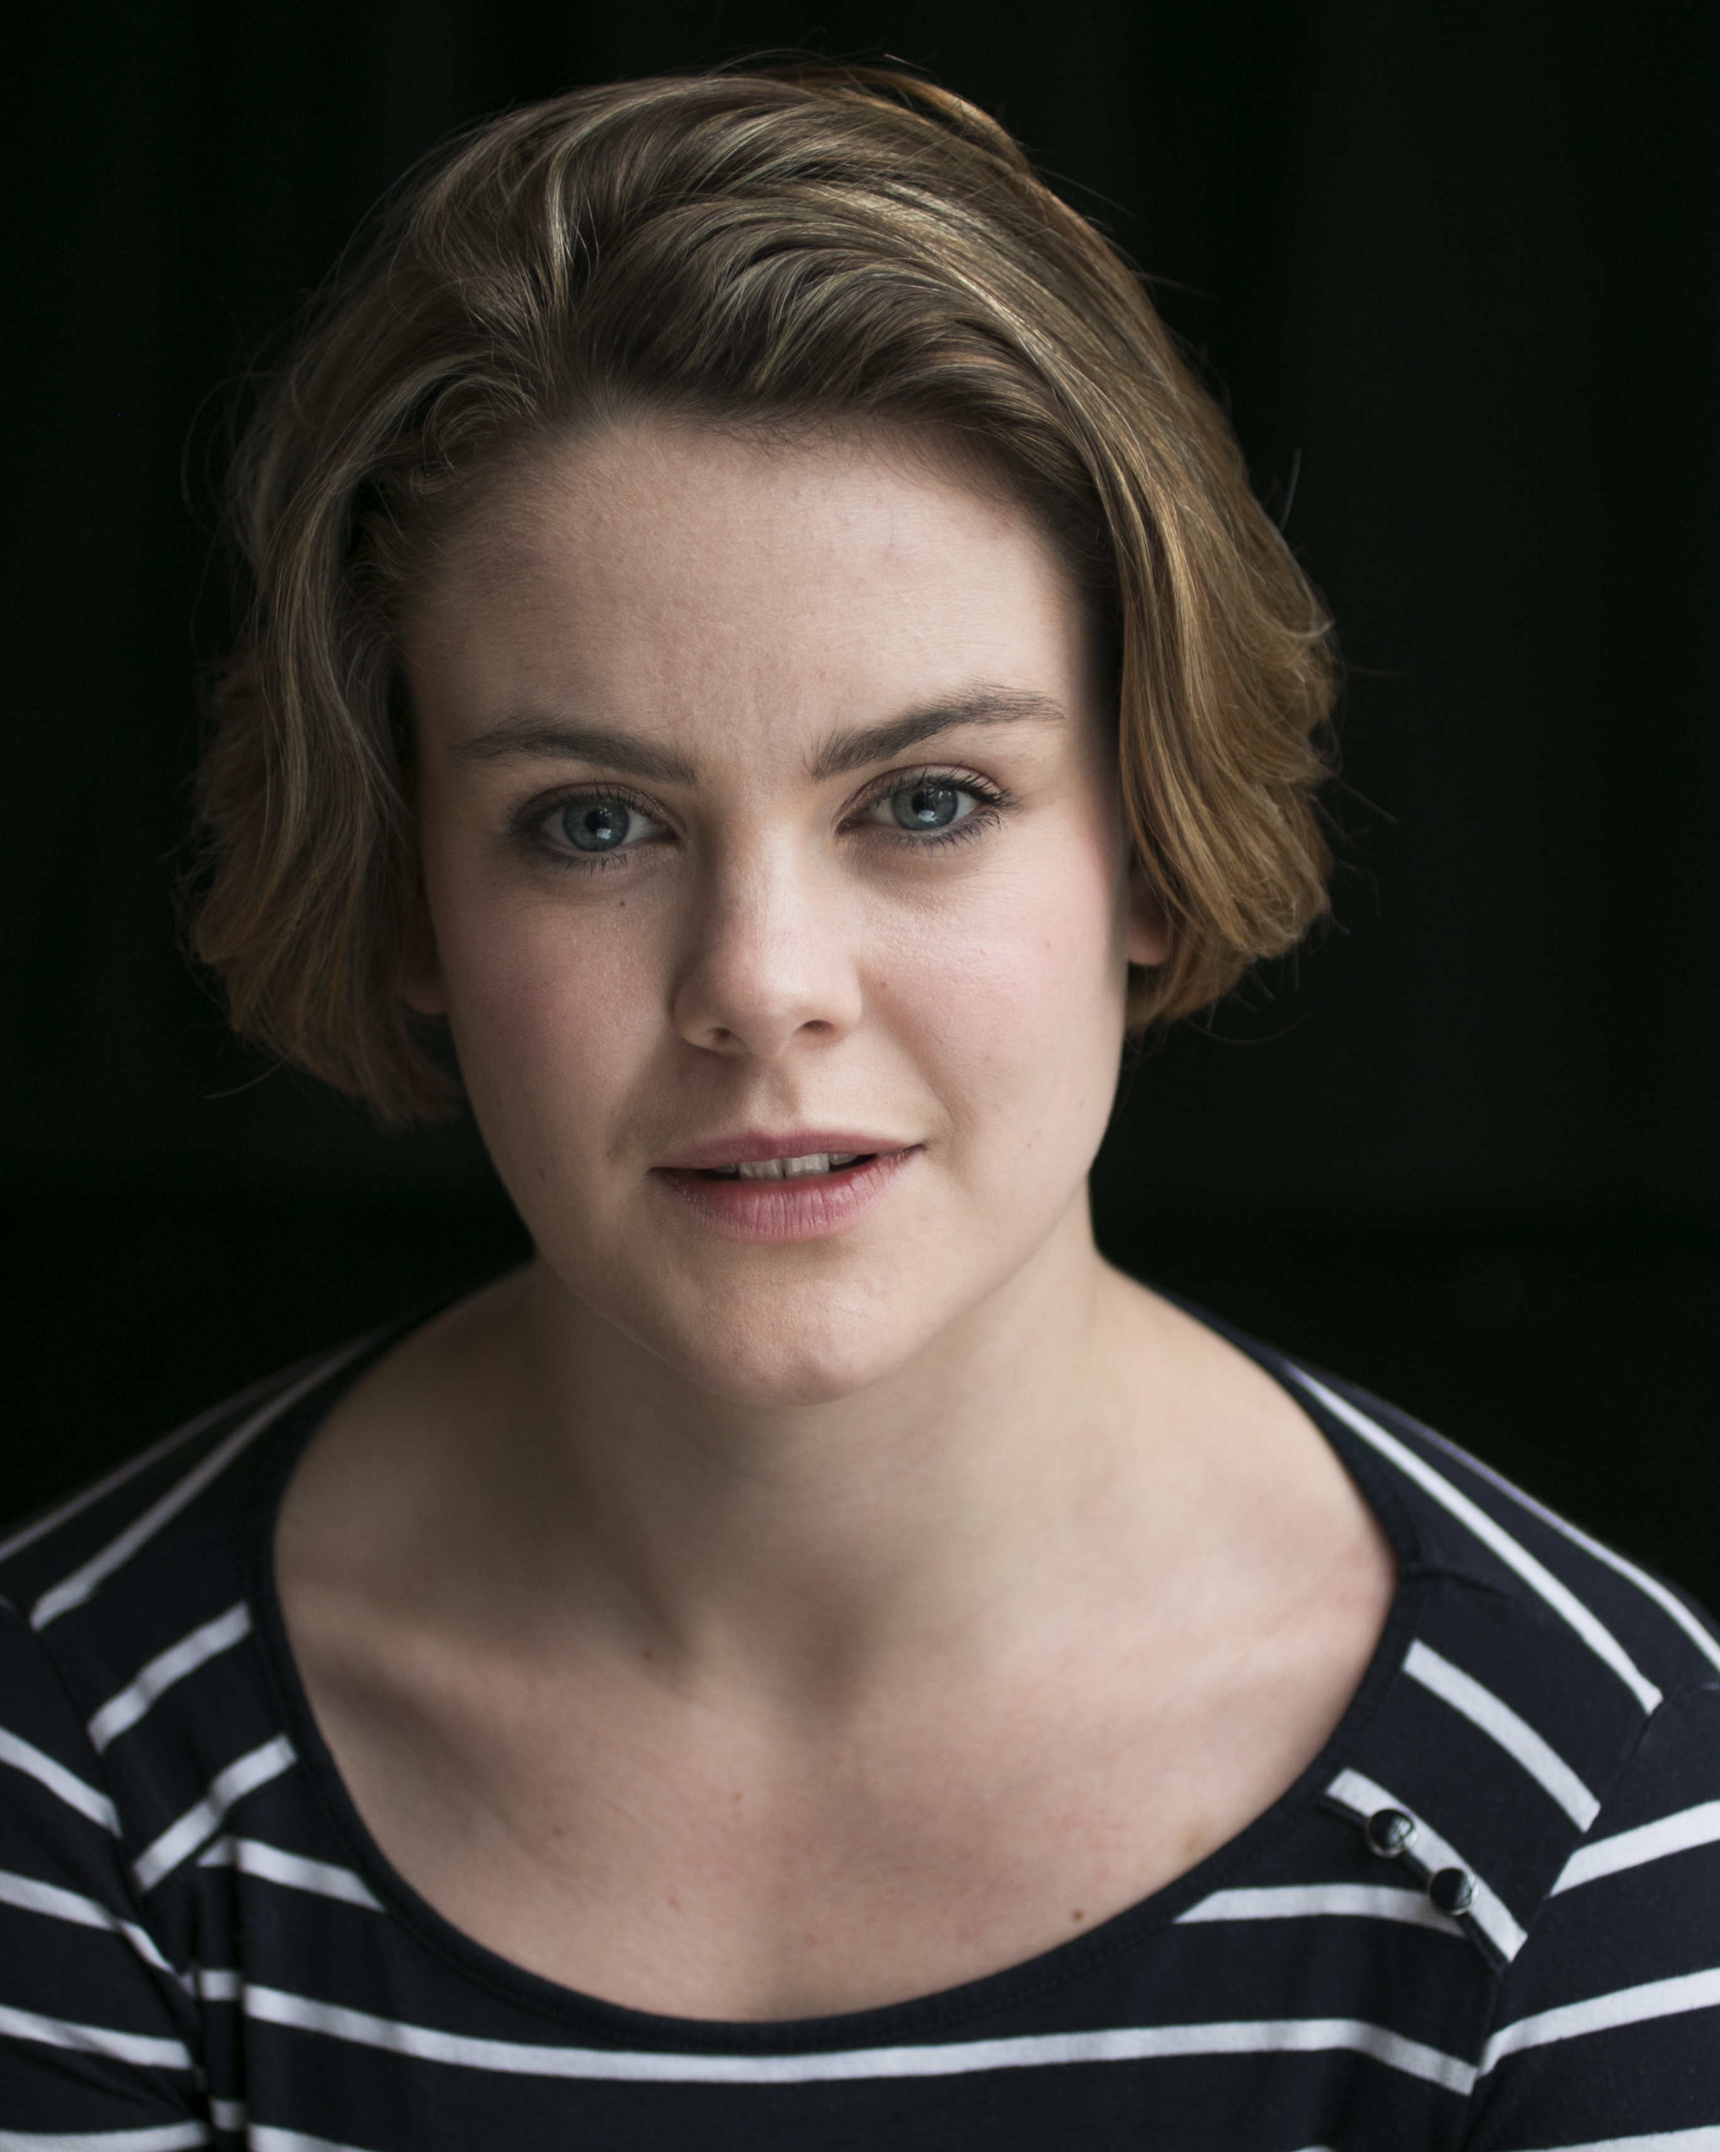

**Agent**:

Gardner Herrity

24 Conway Street

London

W1T 6BG

**Phone:**

02073880088

**Email**:

info@gardnerherrity.co.uk

**Hair**: Brown

**Eyes**: Blue

**Height**: 5’3”

**Spotlight Pin:**

9494-0190-0666

**Graduate of Bristol Old Vic Theatre School**

Molly Hanson

Gardner Herrity

**Theatre Credits:**

*Toby Maitland,* POSH, Pleasance Theatre with Can’t Think Theatre Company,

Directed by Cressida Carré

*Ugly Sister*, Cinderella, Windsor Castle with Watch Your Head,

Directed by Sasha McMurray

*Hermia*, Midsummer Nights Dream, Windsor Castle, with Watch Your Head,

Directed by Sasha McMurray

*Celia,* As You Like It, Savill Gardens, with Watch Your Head,

Directed by Sasha McMurray

*Joan*, premier revival of First Episode, Jermyn Street Theatre, with Primavera Productions,

Directed by Tom Littler

**Television Credits:**

*Hannah Drake,* The Coroner *(Series 1 Episode 3 - That’s The Way To Do It),* BBC,

Directed by Matt Carter.

*Paulette Swain,* Father Brown (*Series 4 Episode 1* – *The Mask of the Demon),* BBC,

Directed by Paul Gibson.

**Other Credits:**

Various Vocals for the *London Road Cast Recording*, Cuba Pictures, BBC Films.